CLIL: Your lesson plan
-------------------------------------------------------------------------------------------------------------------------------
Topic/Lesson Title:
Trip to Bulgaria

Aims/Goals or SWBATs (Students will be able to......)

Learn about a country from the EU. Identify the most important characteristics about the country.

Age group:
13 - 14 years old

Level:
Easy

Time (Lesson duration):
50 min

Materials:
Computer with internet access
Speakers
Copy of the different parts of the used texts

Lead-in What’s going to happen here to introduce your students to the topic? Time 3 min

First, they will listen to a song without video. They should identify what country they are going to discover. Then the teacher will introduce the topic.

https://www.youtube.com/watch?v=fWOKxS7wjLc

What can students predict or do to get started with the lesson? Time 5 min

They can predict what country they are going to discover and what they are going to discuss.

What vocabulary could teachers focus on? What needs to be pre-taught? Time 2 min

Introduce different names of foods from Bulgaria:
Lukanka: is a Bulgarian (sometimes spicy) salami unique to Bulgarian cuisine. It is similar to sujuk, but often stronger flavored.
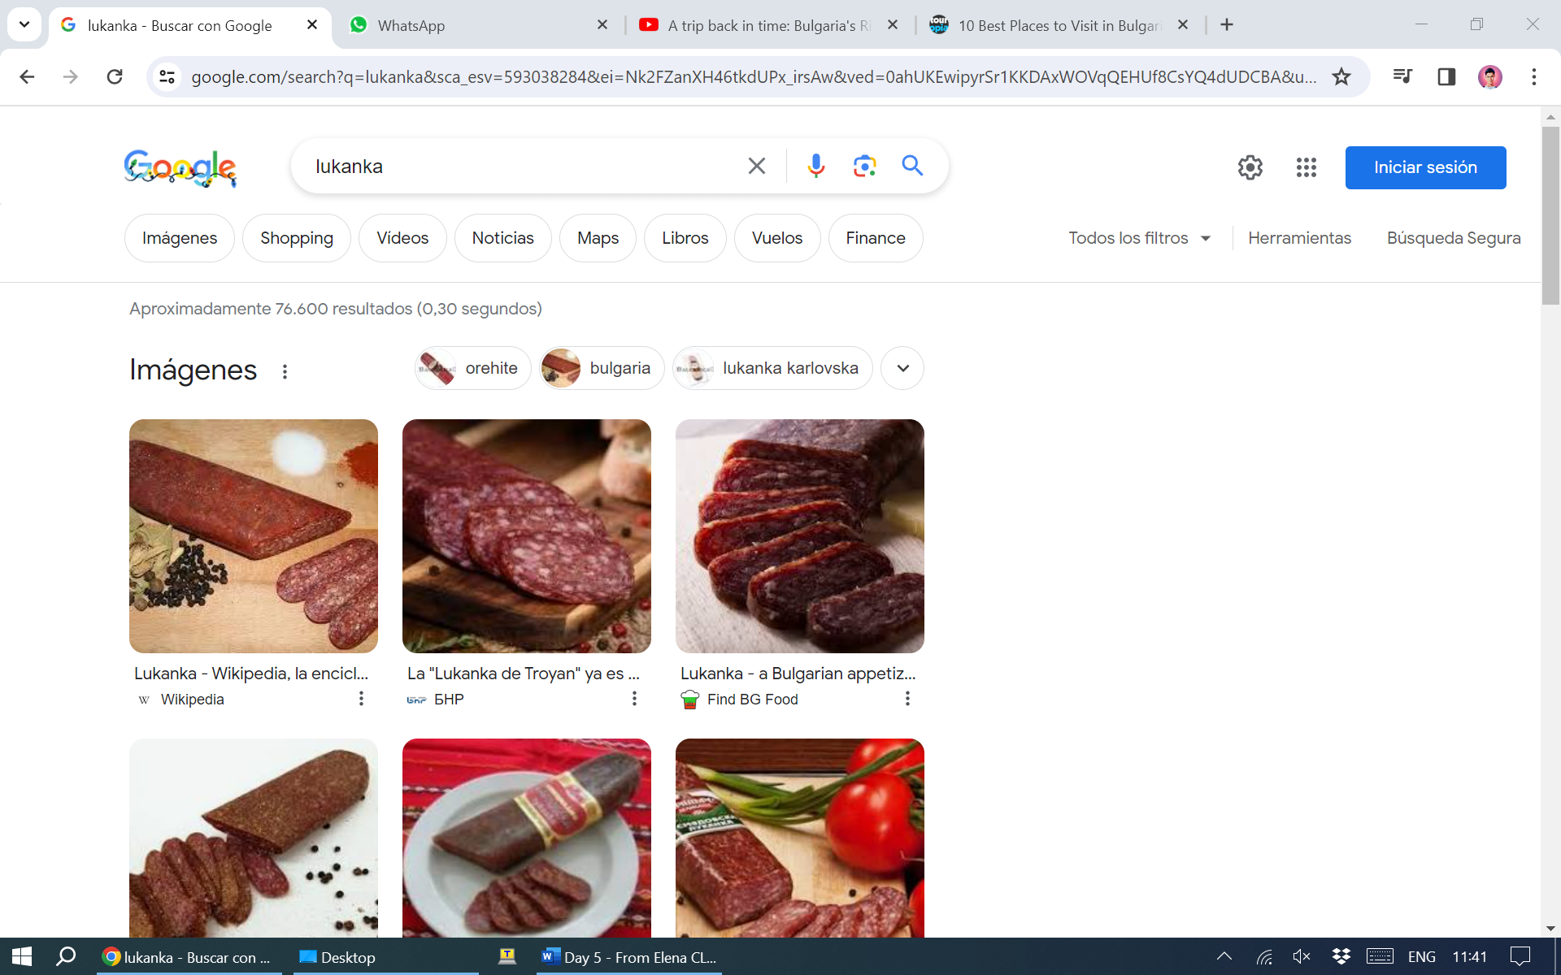
Banitsa: is a traditional pastry dish.
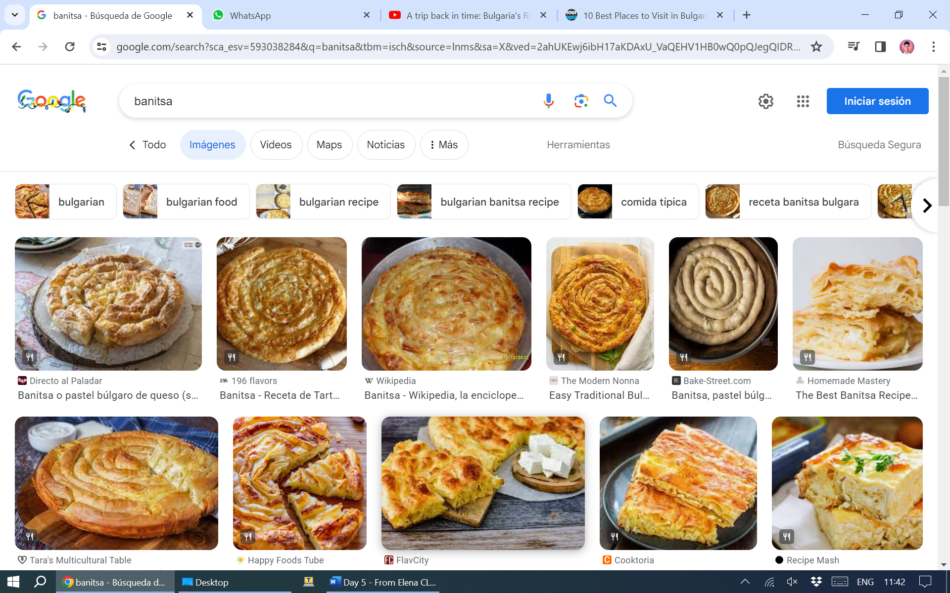
Shopska salad: is a cold salad made from tomatoes, cucumbers, onion/scallions, raw or roasted peppers, sirene (white brine cheese).
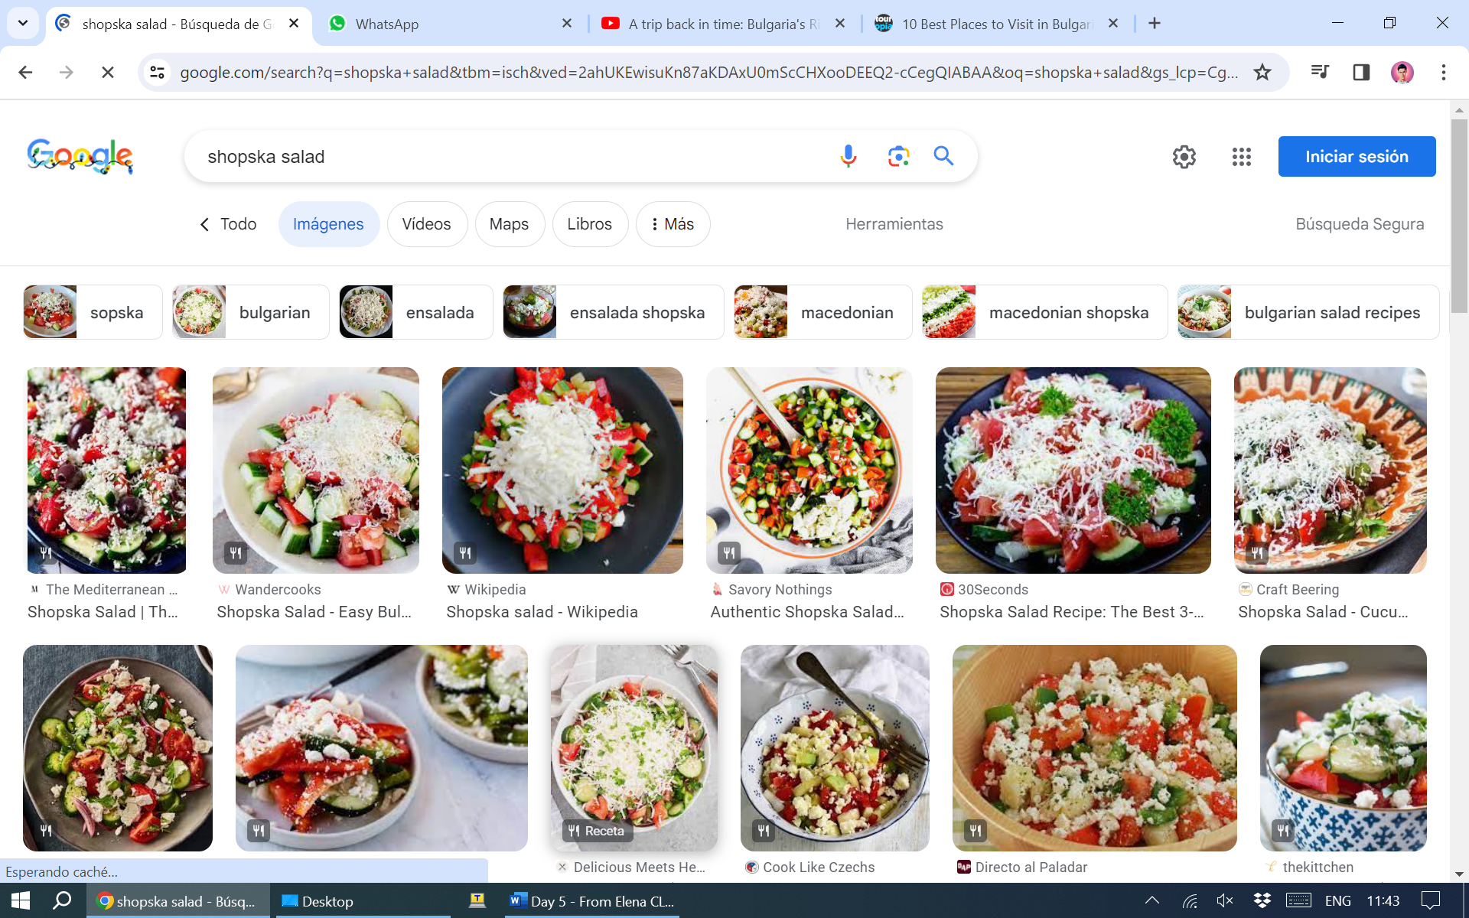
Lyutenitsa: is a (sometimes spicy) vegetable relish or chutney. The ingredients include peppers, aubergines, carrots, garlic, vegetable oil, sugar, salt, and tomatoes. It comes in many varieties: smooth; chunky; with chili peppers or eggplant; and hot or mild.
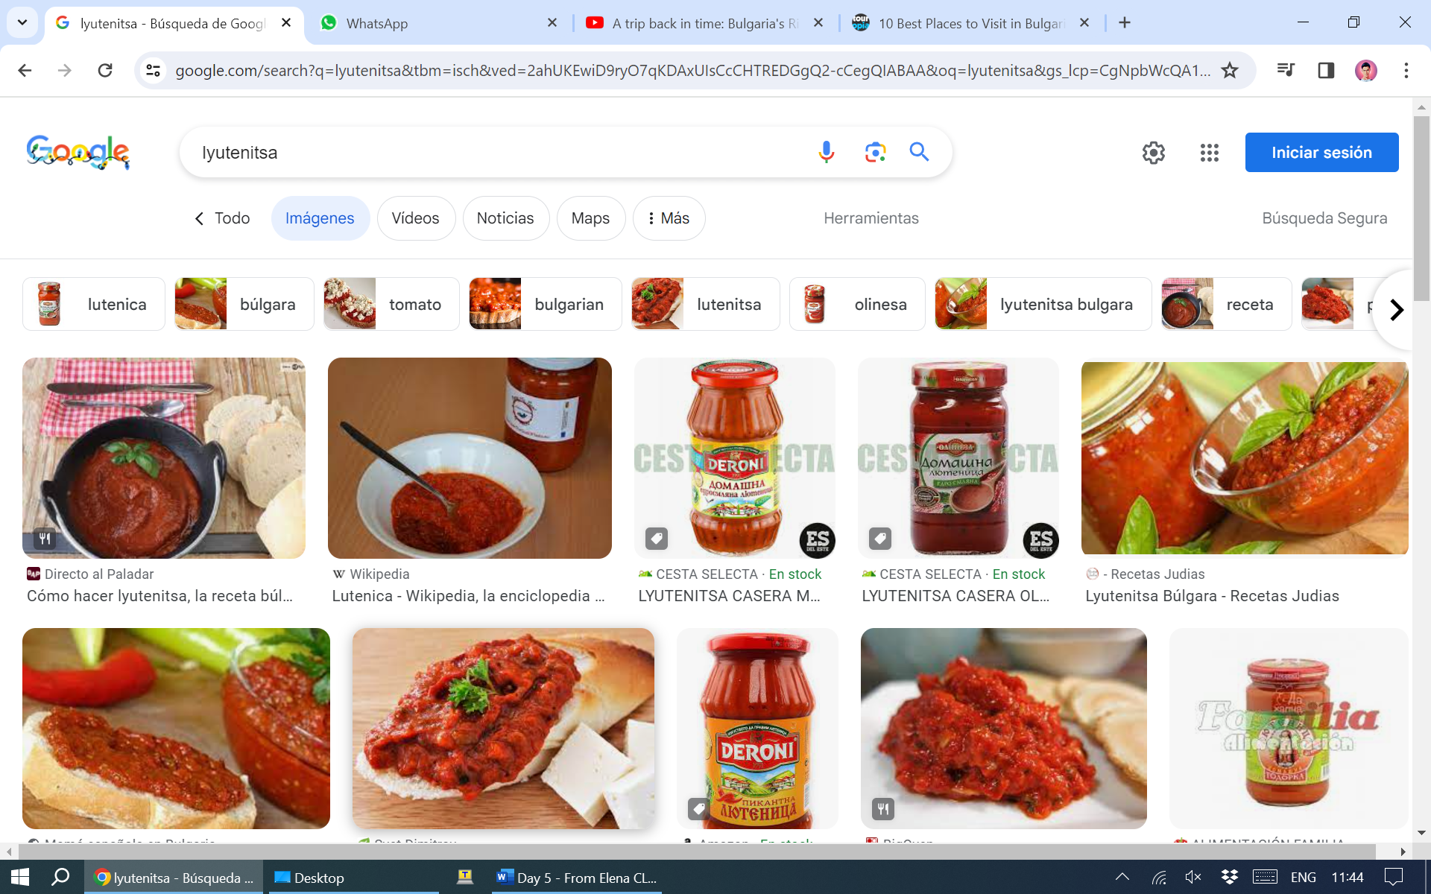
Kozunak: is a sweet yeast dough that can be used to make different traditional holiday breads and cakes.
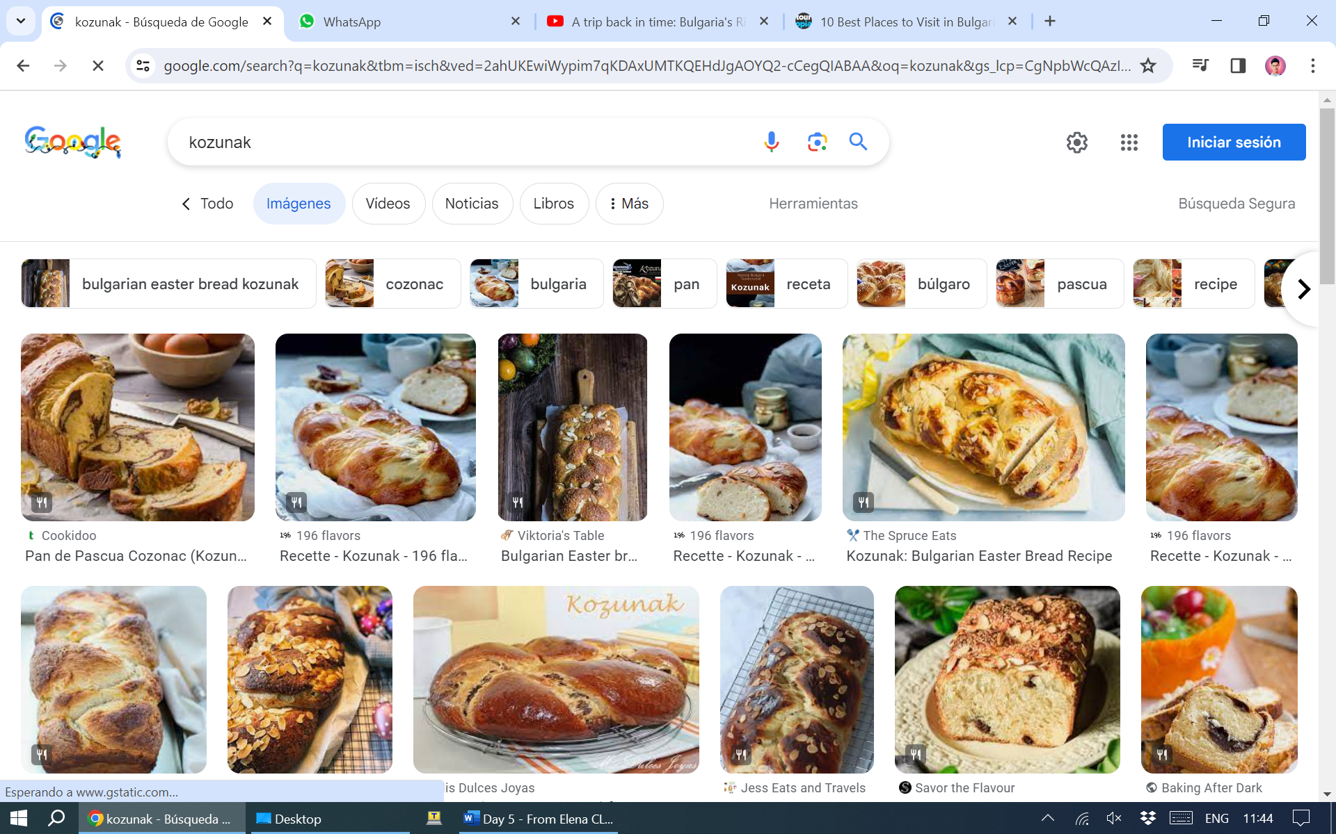

What kinds of texts can students listen to or read to deepen their knowledge? Time 10 min

The teacher will share with the students a text with a brief history of the country. The text is is 5 different parts and each student should have only one part. After reading, they should be in groups with all the different parts of the papers. They should read in loud.

1 Ancient Bulgaria
2 Bulgaria in the Middle Ages
3 Independent Bulgaria I
4 Independent Bulgaria II
5 Modern Bulgaria

Appendix 1

What kinds of questions can students answer from the listening or reading? How many should they answer? What should they notice or analyze? Time 10 min

Then the teacher should share some questions and they have to answer individually. After that, they should compare their answers with a partner, in groups of 5.

Appendix 2

What will students speak about in pairs or in small groups? Time 10 min

After watching the video from the monastery of Rila, they should discuss in pairs a place in Bulgaria that they want to visit and why. Then they will put in common with all the class. The options are on this webpage and teachers can share with the students and they can enter with their mobile phones to see the content. Each person should speak once.

https://www.touropia.com/best-places-to-visit-in-bulgaria/

What will students write about during class time or for homework? Time 10 min

https://www.youtube.com/watch?v=GTCUMnSd3yg

They should listen to the video slowly and complete the text. Then they will be in groups of 3 and share the answers. Finally if necessary the teacher can share the answers from the transcription.

Appendix 3 and 4

What are other follow up (or homework) activities that can be included?

To have knowledge about what the students have learned about the task, they should do a true or false activity at home with 5 questions.

Other thoughts about this lesson plan:

Assessment will be done with a google form soft assessment with three or four easy questions.

Appendix 1
By Tim Lambert

Ancient Bulgaria
From about 400 BC a race called the Thracians lived in parts of what is now Bulgaria. The Thracians were a tribal society and they were superb horsemen. They were also known for making beautiful gold and silver jewelry.
By 100 AD the Romans conquered Bulgaria. The Romans founded the city of Trimontium (modern-day Plovdiv). They also built the city of Serdica on the site of Sofia.
In 395 the Roman Empire split in two. Bulgaria became part of the Eastern Roman Empire (later called the Byzantine Empire). However, Byzantium grew weaker and about 500 AD Slavs settled in Bulgaria.
Then in 680 the Bulgars invaded led by their ruler Khan Asparukh. They were descended from the Huns from Central Asia. They crossed the Danube and founded the state of Bulgaria. They then intermarried with the Slavs.
In 716 the Byzantine Empire recognized the state of Bulgaria.

Bulgaria in the Middle Ages
However, in the late 8th century, Emperor Constantine V tried to destroy Bulgaria – but without success. Then the pendulum swung the other way. From 809 Khan Krum attacked the Byzantine Empire. Led by Khan Krum the Bulgars were victorious. In 811 the Byzantine Emperor, Nicephorus was killed in battle. In 813 Krum even lay siege to Constantinople, the capital of Byzantium but he failed to capture it. Finally, in 816 Khan Omurtag made peace.
Then in 846 Boris I of Bulgaria accepted Christianity and his subjects followed. Bulgaria accepted the Eastern Orthodox Church rather than the Western Catholic Church.
However, in the later 10th century Bulgaria declined. In 971 the Byzantines took the capital Preslav along with a large part of eastern Bulgaria. In 1018 Bulgaria became part of the Byzantine Empire. The Byzantines ruled Bulgaria until 1185.
Then in 1204 the Crusaders captured Constantinople, the capital of the Byzantine Empire. The Crusaders claimed that the Bulgars were their vassals however the Bulgars defeated them in battle.
The second Bulgarian kingdom reached its peak under Ivan Asen II 1218-1241. Bulgaria became prosperous and powerful.
In the 14th century, the Ottoman Turks were a rising power in the region. In 1393 they captured Turnovo. All Bulgarian resistance to the Turks ended in 1396. Bulgaria was under Turkish rule for nearly 500 years.
Nevertheless, the Bulgarians had to pay taxes to the Turks. They also had to surrender their sons. At intervals, the Turks would take the cream of Bulgarian boys aged 7 to 14. They were taken from their families and brought up as Muslims. They were also trained to be soldiers called Janissaries.
Then in the 19th century, nationalism became a powerful force in Europe including Bulgaria and the ideas of the French Revolution spread. There was a growing interest in Bulgarian culture and history and a growing resentment of Turkish rule.
Finally, in April 1876, some Bulgarians rose in revolt. However, the Turks easily crushed the rebellion.

Independent Bulgaria I
Then in April 1877, Russia declared war on Turkey. In January 1878 the Russians captured Sofia. Then on 3 March, the Treaty of Stefano ended the war. The treaty created an independent Bulgaria. However, the British and Austro-Hungarians were afraid that this new Bulgaria might be a powerful ally for Russia and they insisted the treaty be revised.
By the treaty of Berlin, July 1878 Bulgaria was split in two. The northern half was not allowed to be totally independent. Instead, Bulgaria was to be a vassal state of Turkey called a principality. It was to be ruled by a prince with a parliament called the Sobranie.
The southern half of Bulgaria was made only semi-autonomous within the Turkish Empire. It was given the name Eastern Rumelia. On 5 October Prince Ferdinand announced the complete independence of Bulgaria. He became King Ferdinand of Bulgaria.
Meanwhile, at the beginning of the 20th century, Turkish rule in Europe was crumbling. The Turks were faced with rebellions. The Balkan states feared that the great powers might intervene. They wanted to liberate the territories still held by the Turks – and impose their own solutions. So they formed a triple alliance of Serbia, Bulgaria, and Greece.

Independent Bulgaria II
Then in 1914 came the First World War. In October 1915 Germany persuaded Bulgaria to join its side promising territory as a reward. However, an allied blockade caused severe shortages in Bulgaria and eventually near starvation. Then in September 1918, French and British troops entered Bulgaria and on 29 September 1918, Bulgaria signed an armistice. On 3 October 1918, Ferdinand abdicated. His son Boris III replaced him.
In 1919 Bulgaria was forced to sign the Treaty of Neuilly-sur-Seine. She lost significant parts of her territory. Furthermore, Bulgaria was not allowed to have more than 20,000 men in her army and she was forced to pay reparations (a form of compensation for the war). However, the reparations were cancelled in 1932.
Despite its troubles in 1920 Bulgaria was allowed to join the League of Nations, the first of the nations on the losing side to do so.
When the Second World War began in 1939 King Boris was, at first, determined to keep Bulgaria neutral. However, in March 1941, he agreed to allow German troops to pass through Bulgaria on their way to Greece. As a reward, Bulgaria was given territory in Thrace and Macedonia. However, although some anti-Semitic laws were passed in Bulgaria the Bulgarian Jews were not deported to concentration camps. King Boris died in August 1943.
By the summer of 1944, Germany was obviously losing the war and the Russians were approaching Bulgaria. The Communist takeover of Bulgaria was gradual. From the start, they controlled the radio and many newspapers. However, the Communists removed their opponents one by one. New Peoples Courts were formed under the Ministry of Justice to try ‘war criminals’ and ‘collaborators’. All the supporters of the old regime were rounded up and executed or imprisoned in labor camps. They included not just politicians but priests, teachers, and policemen. Furthermore, they removed ‘unreliable’ officers from the army. Eliminating all right-wingers made the Communists even more powerful.
The Communists nationalized industry and collectivized agriculture in Bulgaria. They also persecuted the Orthodox Church.
Finally, after imposing Communism the Communist Party turned on its own members. After the anti-Communist uprising in Hungary in 1956, there was a purge in Bulgaria in which many communists were expelled from the party. Some were sent to labor camps.
So for many years, Bulgaria was burdened with a totalitarian regime, slavishly obedient to the Soviet Union.
Modern Bulgaria
Finally, in the late 1980s, the Communist tyranny in Bulgaria began to crumble. On 10 November 1989 Zhikov was deposed. In April the Communists renamed themselves the Bulgarian Socialist Party. The totalitarian regime was dismantled. On 6 March 1990 strikes were made legal. However multi-party elections were not held until June 1990. The Bulgarian Socialist Party continued to hold power.
However, state socialism was scrapped in Bulgaria. From 1991 controls on prices were removed and industry was privatized. Collective farms were dissolved. A new constitution was introduced in July 1991 and after further elections in October 1991, the Socialist Party lost power.
Bulgaria was a relatively poor country and it suffered badly in the recession of 2009.
However, Bulgaria recovered and today the economy is growing steadily. Today tourism is a rapidly growing industry in Bulgaria. Tourists are attracted by the beautiful architecture and beaches in Bulgaria. Bulgaria joined NATO in 2004 and Bulgaria joined the EU in 2007. In 2020 the population of Bulgaria was 6.9 million.

Appendix 2

Questions
- What are the Thracians known also for?
- What is the name of the emperor who tried to destroy Bulgaria in the 8th century?
- In what year Crusaders captured Constantinople?
- What is the name of the treaty that ended the war with Russia in 1878?
- What happened to Bulgaria in 1919?
- When did Bulgaria start to be a democratic and non-socialist country?

Appendix 3

this is the Rila __________ it's one of
bulgaria's main cultural and religious
sites it was built over one ___________
meters up the Rila Mountains let's
discover its ___________ its architecture
and some of its secrets together
founded in the 10th century the Rila
_____________ is Bulgaria's largest and most
renowned eastern ____________ complex its
striking architecture is considered a
______________ of the Bulgarian national
revival style typical of the early 19th
century when the monastery was rebuilt
after a _________
the way the walls with arches and
___________ are constructed
and the main use of stone
the monastery was founded by Saint John
of Rila his dwelling and tomb became a
holy site and were _____________ into a
monastic complex today it's home to
seven monks who are the ___________ of the
monastery's impressive history and
orthodox art
these magnificent frescoes show
different ___________ of the old and new
testament
there's a very special place in the
monastery the library let's see why
the library of the Rila____________ has
unique rare and extremely precious books
dating from the 10th century until today
despite being one of Bulgaria's main
tourist sites the ___________ has
preserved its tranquil atmosphere built
around the monks' daily lives
[Music]

Appendix 4

this is the Rila Monastery it's one of
bulgaria's main cultural and religious
sites it was built over one thousand
meters up the Rila Mountains let's
discover its history its architecture
and some of its secrets together
founded in the 10th century the Rila
monastery is Bulgaria's largest and most
renowned Eastern Orthodox Complex its
striking architecture is considered a
masterpiece of the Bulgarian national
revival style typical of the early 19th
century when the monastery was rebuilt
after a fire
the way the walls with arches and
colours are constructed
and the main use of stone
the monastery was founded by Saint John
of Rila his dwelling and tomb became a
holy site and were transformed into a
monastic complex today it's home to
seven monks who are the guardians of the
monastery's impressive history and
orthodox art
these magnificent frescoes show
different moments of the old and new
testament
there's a very special place in the
monastery the library let's see why
the library of the Rila monastery has
unique rare and extremely precious books
dating from the 10th century until today
despite being one of Bulgaria's main
tourist sites the monastery has
preserved its tranquil atmosphere built
around the monks’ daily lives
[Music]

