**CLIL: Your lesson plan – Suzana Volarič, OŠ Simona Gregorčiča Kobarid, Slovenia**

-------------------------------------------------------------------------------------------------------------------------------

| Topic/Lesson Title:  Pearls of Nature in Austria |
| --- |

| Aims/Goals or SWBATs (Students will be able to......)   * Understand and name a few different living environments in English (cave, waterfall, mountain, meadow, lake, forest, river, pasture) or some other English words. * Understand what is the English video about. * Match pictures and English words. * Fill in the missing English words in the text. * Make a poster with English keywords. * Speak about the poster. |
| --- |

| Age group:  8 years old |
| --- |

| Level:  Beginners |
| --- |

| Time (Lesson duration):  Two periods of 45 minutes |
| --- |

| Materials:   * Pictures and English words, * Posters and pens, * Video, * Filling gaps * Kahoot |
| --- |

| Lead-in *What’s going to happen here to introduce your students to the topic?* Time 15 min  Picture puzzle  I start the lesson with the whole class (I have only 10 students, if more, you can divide them into small groups). Students get pieces (puzzles) and they have to make 8 pictures representing different living environments and at the same time, these are the most known Austrian natural attractions. (Attachment 1)  I ask them what they see in the pictures. Do they know some English words for what they see (water, grass, cloud, caw, flower, sky, ice, snow, road, cottage, house, …)? What do they think about which animals or plants live in those environments? Are these photos taken near us or very far away? In which country do they think are taken?  In the following, I can tell them more about the places where those pictures were taken. |
| --- |

| *What can students predict or do to get started with the lesson?* Time 5 min  Based on the pictures the students can predict what are we going to talk about. |
| --- |

| *What vocabulary could teachers focus on? What needs to be pre-taught?* Time _____  The students don’t have to have any pre-knowledge. We lead the activities based on what students already know.  The vocabulary is basic; colours, nature, animals, plants (already listed suggestions at aims/goals and lead-in activity). |
| --- |

| *What kinds of texts can students* ***listen*** *to or* ***read*** *to deepen their knowledge?* Time 15 min  Match the words with the pictures (Reading and speaking activity)  After resolving picture puzzles students get written words. (Attachment 2) They work in two teams. (If it is too easy or too hard for your students you can reorganize teams.) Each team gets 4 pictures and 4 words. They have to match the words with the pictures and at the end present it to the other group reading the matching pairs. Every student has a chance to read at least one word. If necessary we correct possible mistakes (or even better – other students suggest the correct word).  Watching the video about Austria  The students watch the video about Austria – link <https://www.youtube.com/watch?v=xEOmUpRLVnI>  I slow the playback speed. |
| --- |

| *What kinds of questions can students answer from the* ***listening*** *or* ***reading****? How many should they answer? What should they notice or analyze?* Time 15 min  Filling the gaps with missing words  Students get the transcription with missing words. They work individually. (Attachment 3) We only listen to half of the video till 3:15. The playback speed is decelerated and the subtitles are on.  Students listen to the video two or three times, depending on their needs. |
| --- |

| *What will students* ***write*** *about during class time or for homework?* Time 25 min  Making a poster about Living environments  In small groups (of 3 or 4 students) they make a poster with the English title “Living environments” and English keywords (cave, waterfall, mountain, meadow, lake, forest, river, pasture). They draw all the mentioned environments and they can write also other English words around the drawings. |
| --- |

| *What will students* ***speak*** *about in pairs or in small groups?* Time 15 min  Presentation of the poster  Every group present their poster to the others using English keywords. |
| --- |

| *What are other follow up (or homework) activities that can be included?*  We will continue with the presentations of the European countries made by the students. Every student will teach us to say something in the language of the country which he chose. |
| --- |

| Other thoughts about this lesson plan:  Evaluation  At the beginning of the next lesson, we do an easy and quick TRUE or FALS Kahoot quiz to see what the students learn and remember.  <https://create.kahoot.it/share/living-environments/2c948a56-c96f-462a-835e-ce7c75dcfe8d> |
| --- |

Attachment 1

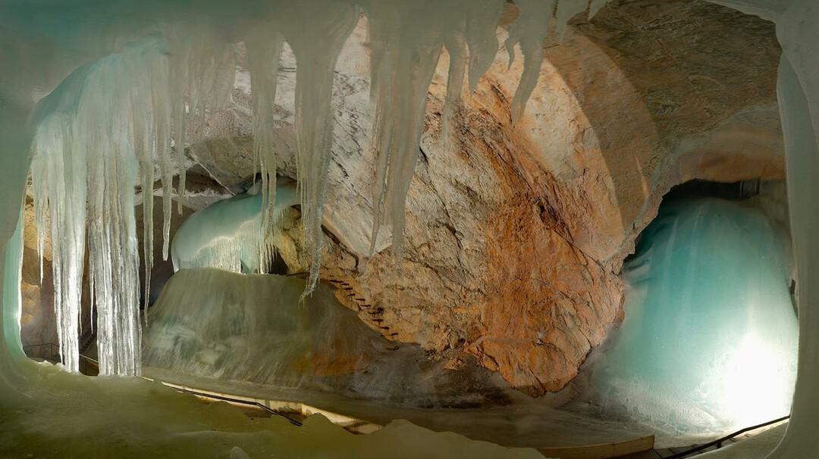

Source:

<https://www.salzburg.info/en/sights/excursions/ice-caves-in-werfen>

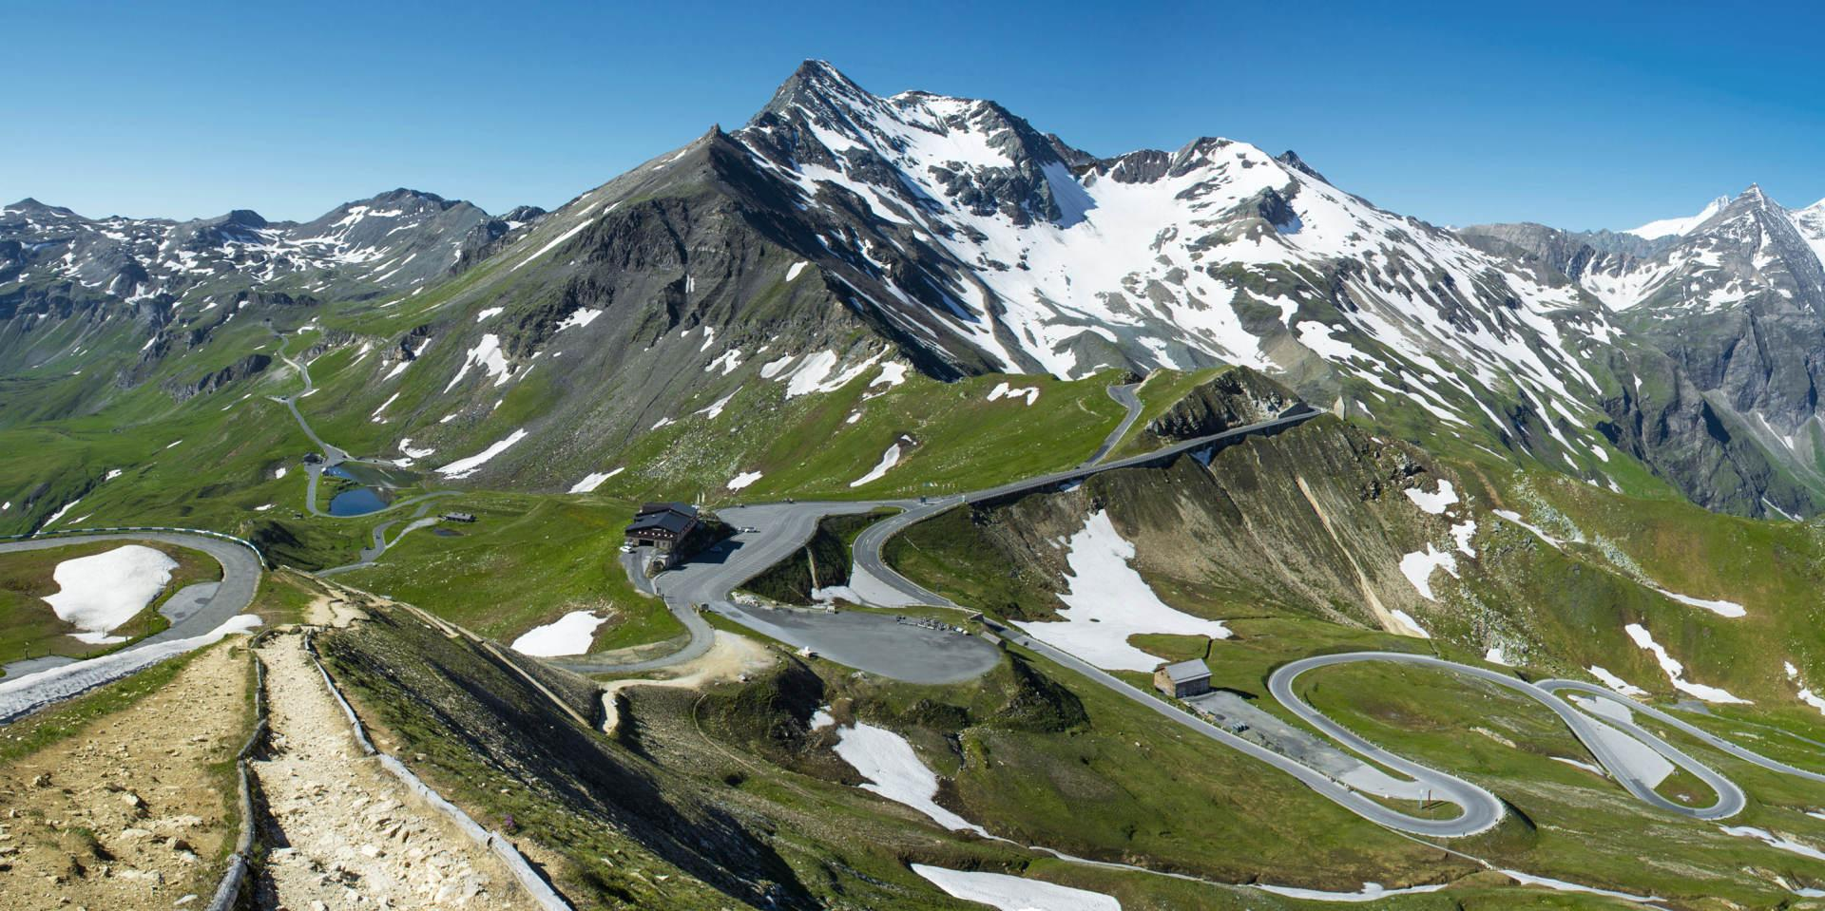

Source:

https://www.panoramatours.com/en/salzburg/tour/grossglockner-high-alpine-road-private-full-day-tour/

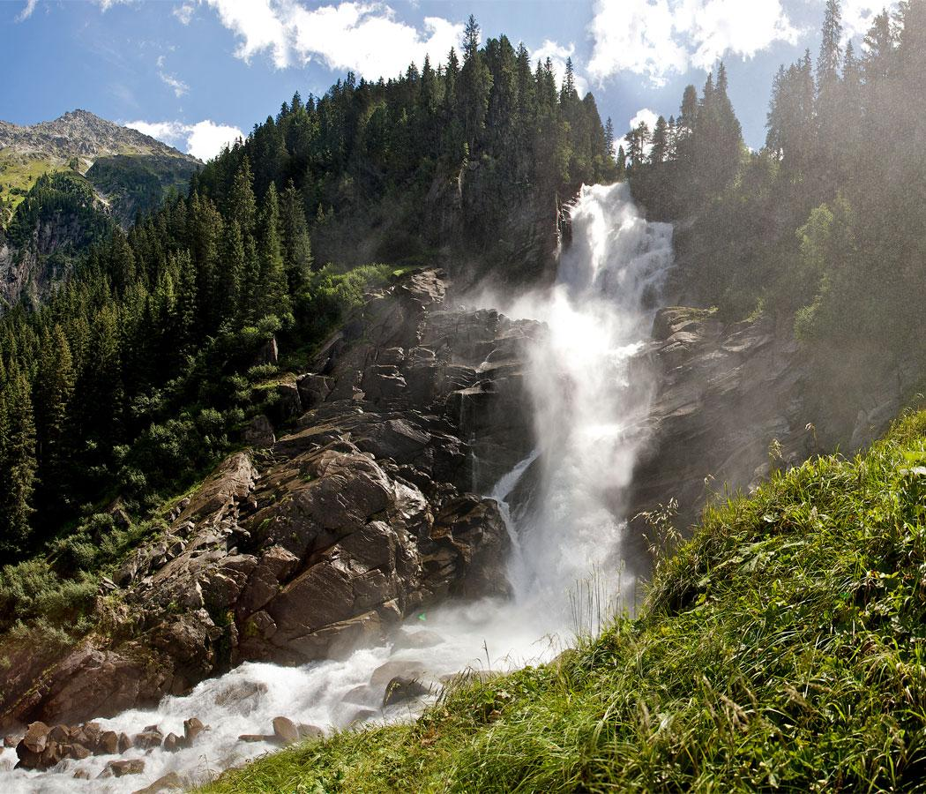

Source:

<https://www.wasserfaelle-krimml.at/en/be-amazed/nature-protection-diploma>

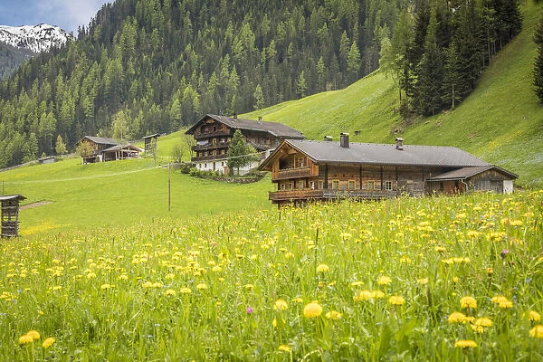

Source:

<https://www.mediastorehouse.com/discover-images-by-awl/summer-meadow-mountain-farms-arntal-25517283.html>

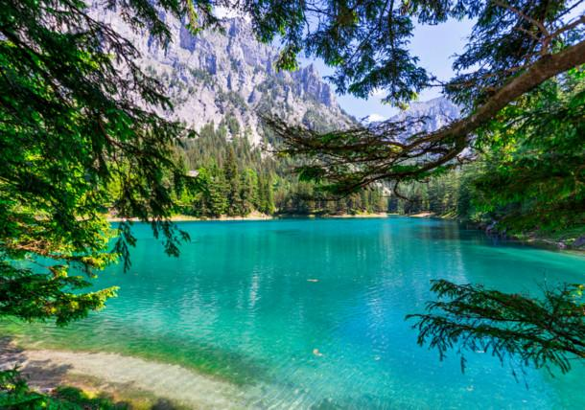

Source:

<https://www.austria.info/en/things-to-do/lakes-and-nature/most-beautiful-places>

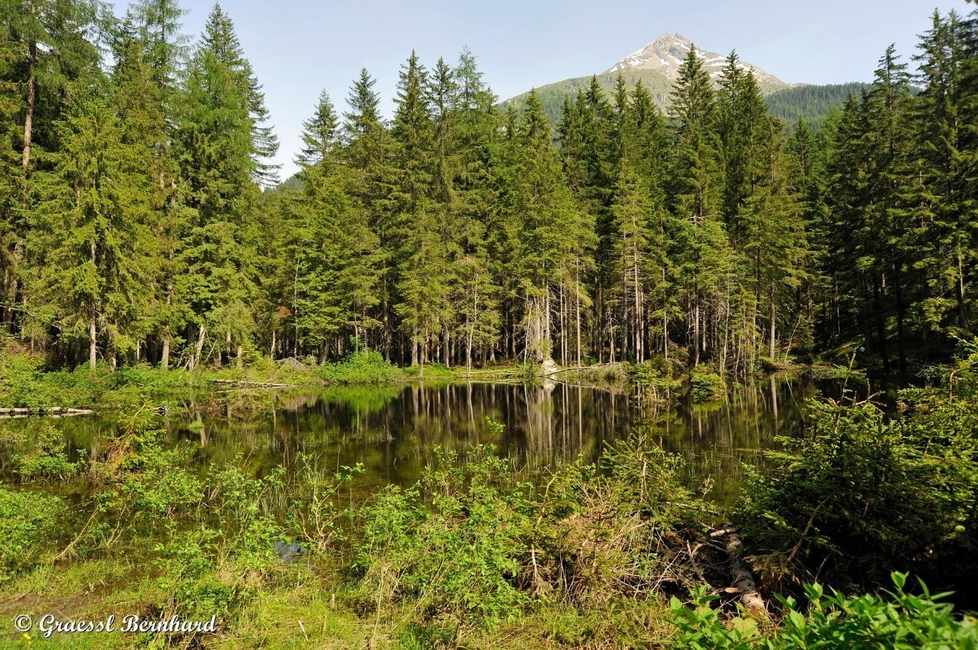

Source:

<https://www.bergfex.at/sommer/kaernten/touren/wanderung/21723,naturlehrweg-natura-mystica-goessnitzfall-kachlmoor/>

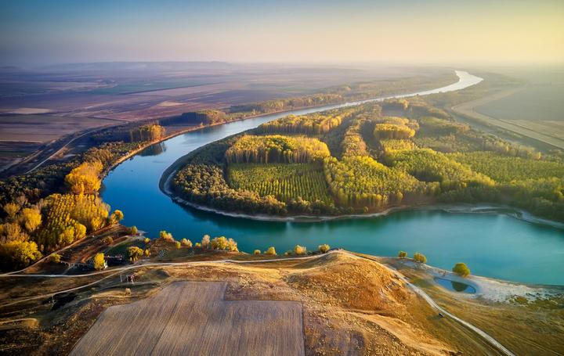

Source:

<https://worldinmaps.com/rivers/danube/>

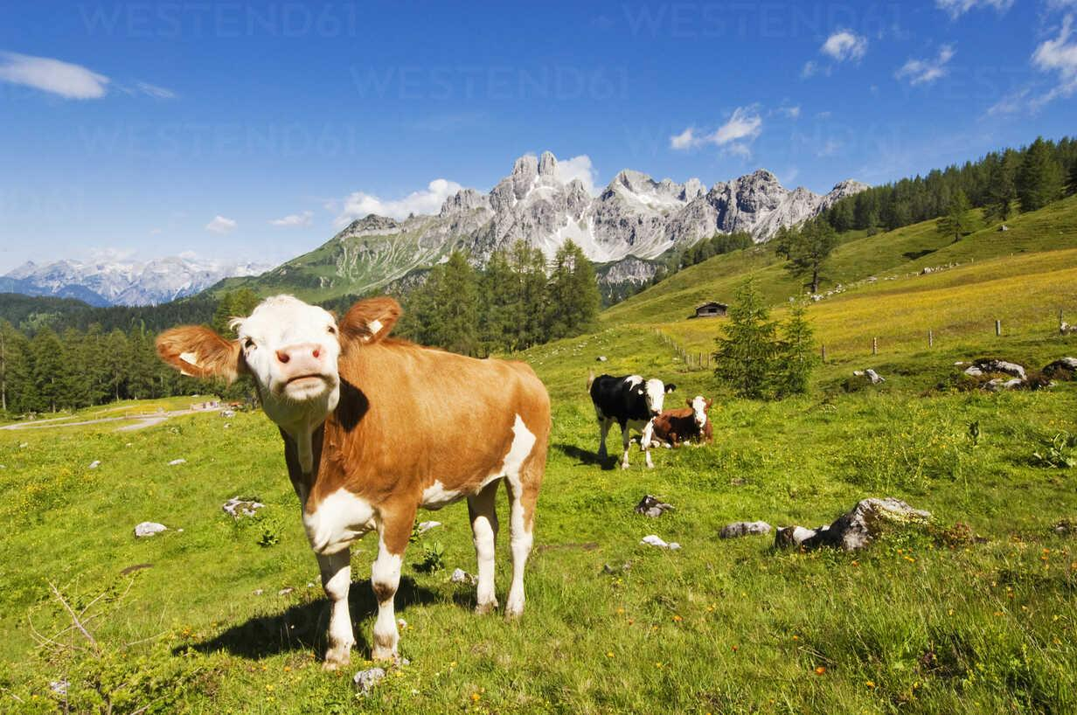

Source:

<https://www.westend61.de/en/photo/HHF004144/austria-salzburg-county-cows-on-alpine-pasture-in-front-of-mount-bischofsmutze>

Attachment 2

| **ICE CAVE** |
| --- |
| **MOUNTAIN ROAD** |
| **WATERFALL** |
| **MEADOW** |
| **LAKE** |
| **FOREST** |
| **RIVER** |
| **PASTURE** |

Attachment 3

| LAKES LAKE    ROAD AUSTRIA  MOUNTAIN WATERFALL |
| --- |

What's up guys. My name is Ryan and I recently returned from a trip to the beautiful country of Austria and I want to show you my favorite places. So, here's my Austria top 10.

Austria is one of the most beautiful countries I've been to. It is so green. They have some of the prettiest mountains and lakes you'll ever see. Now, to get there I'd recommend flying into either Vienna or Salzburg, preferably Salzburg because it's closer to the Alps.

So for our first location we're going to head over to go south. It is one of the most beautiful towns like it is so gorgeous. When you think about the European Alps this is it. It had some of the prettiest churches I've ever seen. There was hardly anybody. I had the whole place to myself. It was absolutely beautiful. So I definitely recommend taking a little pit stop here if you're near Helstadt.

All right, so after it goes out we're gonna head up the road 15 minutes to see the Gosouseen lake. It's just a quick drive from go south you'll pass a beautiful lake with a nice little bench and there's a parking lot where you can park your car. Gosouseen is just this beautiful lake that is situated between the Dockstein Glacier and the mighty peaks of ghost.com. Probably butchered those words. There's a beautiful trail and you can walk around the whole lake. They have an awesome lodge where you can get food and you can also rent a boat and enjoy the lake even more. One thing that I do regret is I didn't take the gondola up because there's an absolutely beautiful view on top. And there's also the infamous Austria sky ladder which I would have known about if I was there. So make sure you guys visit that lake if you have a chance. It is so pretty.

All right, so after Gosouseen, we're heading over to the Grossglockner High Alpine Road. It's the highest road in Austria at 2504 meters and it's one of the highest in Europe. It's named after Grossglockner which is the highest peak in Austria at 3798 meters. When I was there I slept at the base of the mountain and I woke up around 6 am to catch the sunrise. It cost me about 35 euros to enter the park. I was absolutely shook by the beauty and the colors of the mountains when I reached the top. The roads were a little scary but nothing too crazy.

After enjoying Grossglockner I made this short drive over to the pasteurized glacier. It's the biggest glacier in Austria. They had a nice parking garage and I found this trail that led to the base of the glacier. So I hiked down to the bottom. The glacier was so cool. I loved the lake at the bottom. It was so grey and so pretty. The surrounding mountains are absolutely huge. You're able to see the Grossglockner mountain there and I just had a good time having all to myself. So, definitely a really cool place to visit if you're in the Grossglockner International Park.

All right, so after Grossglockner and pastor reese we're gonna head over to Krimml Falls. So these are the highest waterfalls in Austria at 300 meters high. There are three stages to the waterfall the biggest being over 140 meters. So the entrance fee is about 4 euros and it's about a 30-minute hike to the lowest waterfall which is the biggest and most impressive in my opinion. You can also hike to the top if you're feeling like an adventure. There's a nice little lodge where you can have lunch. If you like waterfalls I definitely recommend visiting Krimml Falls.

| LAKES LAKE    ROAD AUSTRIA  MOUNTAIN WATERFALL |
| --- |

What's up guys. My name is Ryan and I recently turned from a trip to the beautiful country of _________and I want to show you my favorite places. So, here's my __________ top 10.

__________ is one of the most beautiful countries I've been to. It is so green. They have some of the prettiest mountains and _________ you'll ever see. Now, to get there I'd recommend flying into either Vienna or Salzburg, preferably Salzburg because it's closer to the Alps.

So for our first location we're going to head over to go south. It is one of the most beautiful towns like it is so gorgeous. When you think about the European Alps this is it. It had some of the prettiest churches I've ever seen. there was hardly anybody. I had the whole place to myself. It was absolutely beautiful. So I definitely recommend taking a little pit stop here if you're near Helstadt.

All right, so after it goes out we're gonna head up the ________ 15 minutes to see the Gosouseen ________. It's just a quick drive from go south you'll pass a beautiful ________ with a nice little bench and there's a parking lot where you can park your car. Gosouseen is just this beautiful ________ that is situated between the Dockstein glacier and the mighty peaks of ghost.com. Probably butchered those words. There's a beautiful trail and you can walk around the whole _________. They have an awesome lodge where you can get food and you can also rent a boat and enjoy the ________ even more. One thing that I do regret is I didn't take the gondola up because there's absolutely beautiful views on top. And there's also the infamous ___________ sky ladder which I would have known about if I was there. So make sure you guys visit that _________ if you have a chance. It is so pretty.

All right, so after Gosouseen we're heading over to the Grossglockner High Alpine __________. It's the highest _________ in ___________ at 2504 meters and it's one of the highest in Europe. It's named after Grossglockner which is the highest peak in ____________ at 3798 meters. When I was there I slept at the base of the _____________ and I woke up around 6 am to catch the sunrise. It cost me about 35 euros to enter the park. I was absolutely shook by the beauty and the colors of the mountains when I reached the top. The roads were a little scary but nothing too crazy.

After enjoying Grossglockner I made this short drive over to the pasteurized glacier. It's the biggest glacier in __________. They had a nice parking garage and I found this trail that led to the base of the glacier. So I hiked down to the bottom. The glacier was so cool. I loved the _______ at the bottom. It was so grey and so pretty. The surrounding mountains are absolutely huge. You're able to see the Grossglockner _______________ there and I just had a good time having all to myself. So, definitely a really cool place to visit if you're in the Grossglockner International Park.

All right, so after Grossglockner and pastor reese we're gonna head over to Krimml Falls. So these are the highest waterfalls in ____________ at 300 meters high. There are three stages to the _____________ the biggest being over 140 meters. So the entrance fee is about 4 euros and it's about a 30-minute hike to the lowest ______________ which is the biggest and most impressive in my opinion. You can also hike to the top if you're feeling like an adventure. There's a nice little lodge where you can have lunch. If you like waterfalls I definitely recommend visiting Krimml Falls.