Lesson plan
-------------------------------------------------------------------------------------------------------------------------------

Author: Jurgita Jaruševičienė

Lesson title: Pets

Lesson brief description
The lesson is about the responsibilities of keeping pets. First I ask the class if anybody has a pet and if yes, what animal is it? Then I will show a picture of Justin Bieber with his pet monkey and ask another question: what animals can be kept as pets? After brainstorming on the previous question, I will ask what are the owner’s responsibilities and duties of pet keeping in the EU? The students will do the brainstorming about the EU regulations on keeping pets. Homework will be to find out the key rules of official EU regulations of pet keeping. Next lesson the students will create their desired pets of LEGO bricks and present them to their classmates. They will have to describe a pet, and tell how to look after it properly according to EU regulations and pets’ rights.

Time (Lesson duration):
2 lessons (45 minutes each)

Methodology: (group, individual, peer assessment, brainstorming, etc…)
Brainstorming, individual and group work, presentation, peer and teacher assessment.

Materials needed:

LEGO bricks, projector.

Students’ age:
9 – 10 years old.

Aims/Goals or SWBATs (Students will be able to......)

- Describe the animal.
- Name the EU regulations of pet keeping.
- Understand the responsibilities of having a pet.
- Create a pet from LEGO bricks.

Lead-in What’s going to happen here to introduce your students to the topic? Time 20 min.

I will show a picture of Justin Bieber with his pet monkey and ask the class a question: who has a pet? After students brainstorm, I will divide them into groups of 3 and ask another question: what animals can be kept as pets? In the groups, students share their ideas about possible pets.

What key-concepts could teachers focus on? What needs to be pre-taught? Time 25 min.
The teacher could focus on monitoring the discussion and provide certain links to EU regulations. Some vocabulary should be pre-taught (body parts, colours, verbs connected with pet keeping).

List of activities with brief description of each one and time for each one:

- Picture of J. Bieber and students’ answers of what pets they have (5 min.)
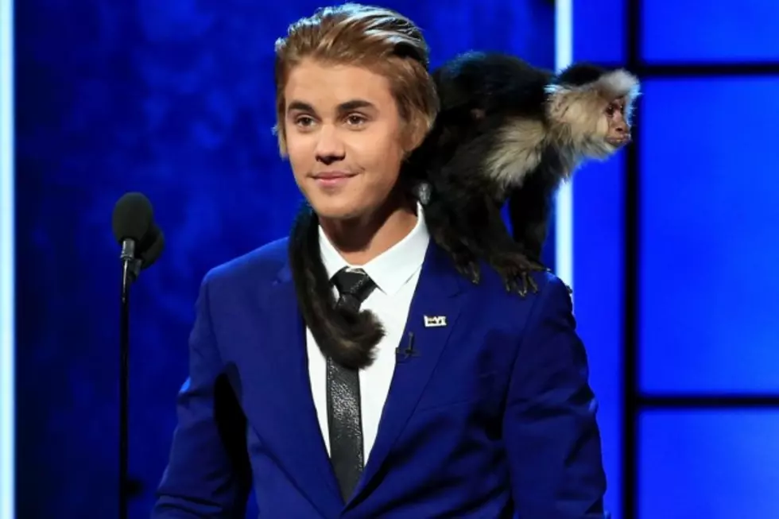
- Brainstorming in groups of 3 on what animals can be kept as pets (15 min.)
- Brainstorming in groups or pairs about the regulations and responsibilities of pet keeping. (20 min.)
- Homework: to search online for real EU regulations of pet keeping. (5 min.)
- Next lesson:
- Making a LEGO pet. (25 min.)
- Present a LEGO pet to the classmates (describe it and tell how to look after it properly and legally). (20 min.)

What are other follow up (or homework) activities that can be included?

Homework would be to search on the Internet for official EU regulations of pet keeping and adapt them for the animal they have chosen as a desired pet.

What methodology / activities are used for assessment?
Assessment would be of two parts. Part 1 (peer assessment on the pre-given criteria): presentation of the LEGO pet (description and regulations of keeping it). Part 2 (teacher assessment): grammar and fluency of speaking.

Other thoughts about this lesson plan:

The teacher should also get acquainted with the EU regulations of pet keeping and animal rights.

