**Lesson plan**

-------------------------------------------------------------------------------------------------------------------------------

| Author: Sylvaine Béal |
| --- |

| Lesson title: “The same but different” |
| --- |

| Lesson brief description  We’re going to discover the diversity of Europe, thanks to a simple recipe: how three basic ingredients like milk, eggs and flour can be interpreted and transformed differently all through Europe. *Crêpe* is going to be an “excuse” to know more about the different European countries, giving sense to the European motto ***United in diversity***. |
| --- |

| Time (Lesson duration): 3 lessons of 1h |
| --- |

| Methodology: (group, individual, peer assessment, brainstorming, etc…)   * Brainstorming * Group of 2 students * Peer assessment * Final product = Google site+crêpe |
| --- |

| Materials needed:   * Infography = Crêpes over Europe * Videos = different ones about the history of crêpes * Common video = the recipe of French crêpes * Ingredients = milk, eggs and flour |
| --- |

| Students’ age:  From 14 to 99 – A1 level |
| --- |

| Aims/Goals or SWBATs (Students will be able to......)   * know where crêpes come from * be conscient about the diversity over Europe * present a European country * realise a recipe * make their own crêpes! |
| --- |

| Lead-in *What’s going to happen here to introduce your students to the topic?* Time ______  Brainstorming = What comes to your mind when mentioning the word “**crêpe**”? (wooclap, 5 min) |
| --- |

| *What key-concepts could teachers focus on? What needs to be pre-taught?* Time 30 min  - Food vocabulary  - Imperative tense |
| --- |

| *List of activities with brief description of each one and time for each one:*   * The origin of the crêpes (20 min) in pairs, each one watches a different video and share their ideas in common to retell the origin of the crêpes. Then they have to write the story (Google site) * The recipe of French crêpes (in common). From the video, rewrite in group the recipe in the imperative tense (20 min) * Infography = the same but different, about the different crêpes all over Europe.   Each group is going to work on a different country to present it to the class (20 min+ 20 min homework)   * Presentation in class = Each group presents his/her country, specifying the way they’re making crêpes in this country (1h) * Final test = let’s taste each recipe! |
| --- |

| *What are other follow up (or homework) activities that can be included?*  - Write out a quick description of the European country you’ve chosen filling the chart:  **Geography**  - What is the capital city?  - How is the country geographically situated?  **Demography**  - What is the population of the country?  - What are the major ethnic groups?  - What languages are spoken?  **History**  - When did the country gain independence?  - When did it enter in Europe?  Government and Politics  - Who is the current head of state/government  **Cuisine**  - What are the traditional dishes?  - What about crêpes? |
| --- |

| *What methodology / activities are used for assessment?*  The students will have to present their google site with the different activities.  The peers will have a chart to assess their mates.  The final product will be the Google site and the crêpe to taste. |
| --- |

| Other thoughts about this lesson plan:  The outcome will be tasting the different crêpes. Each group will have to make a crêpe the same way as they do in the country they were working on. They can record themselves making the recipe and insert the video in the Google site. They’ll have to bring their crêpes in class and we will taste them all together, giving them a podium. |
| --- |

* 2 videos about crêpes history =

[video 1](https://youtu.be/0A-EUW1l2-w?si=LFFAOQMzPIT8Ekvf)

[video 2](https://youtu.be/0A-EUW1l2-w?si=LFFAOQMzPIT8Ekvf)

* Infography :

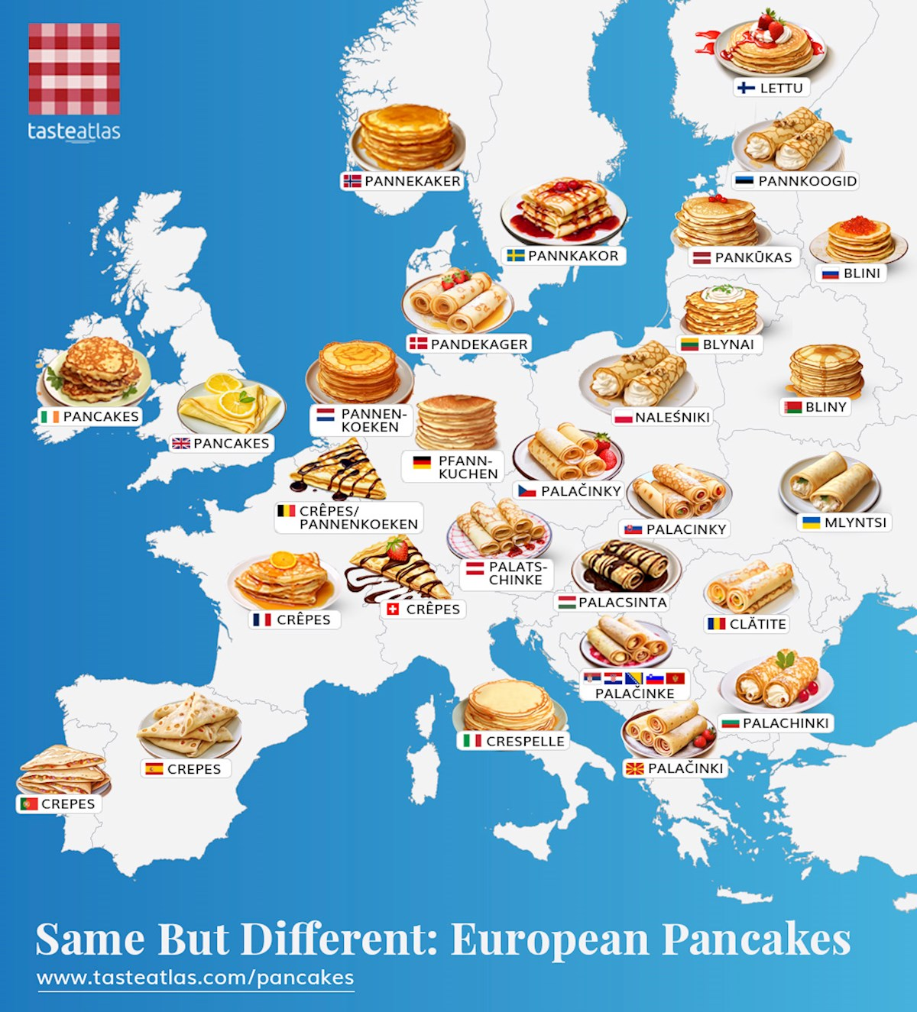

* [Crêpe recipe video](https://youtu.be/YbxWMDdVSPY?si=ajSs3uJ4o6ECXVAg)